Standard Operating Procedure:
“Continuous Integration and Deployment Procedure-Jenkins & HCL launch”

Document date: October -2023

Version Reference: 1.0

Private & Confidential - This process note is the property of L&T Finance. The document is to be used for internal purposes only. Any unauthorized, copying, disclosure, use or distribution of the material is strictly forbidden.

Introduction

Deployment process should be carried out through Automation. In this SOP we have explained all steps to undertake complete CICD pipeline by Application team.

Purpose and scope:

Main purpose is to implement Continuous Integration and Continuous Delivery for Mulesoft Application through automation.

Login & Welcome Page(Jenkins)

Application URL: http://172.30.90.21:8080/
User Name: PS ID/VEN ID.
Password: Password will be shared by DevOps team personally

Pre Req: To access the Jenkins, the person needs to enable the IP 172.30.90.21& Port 8080 in ZPA

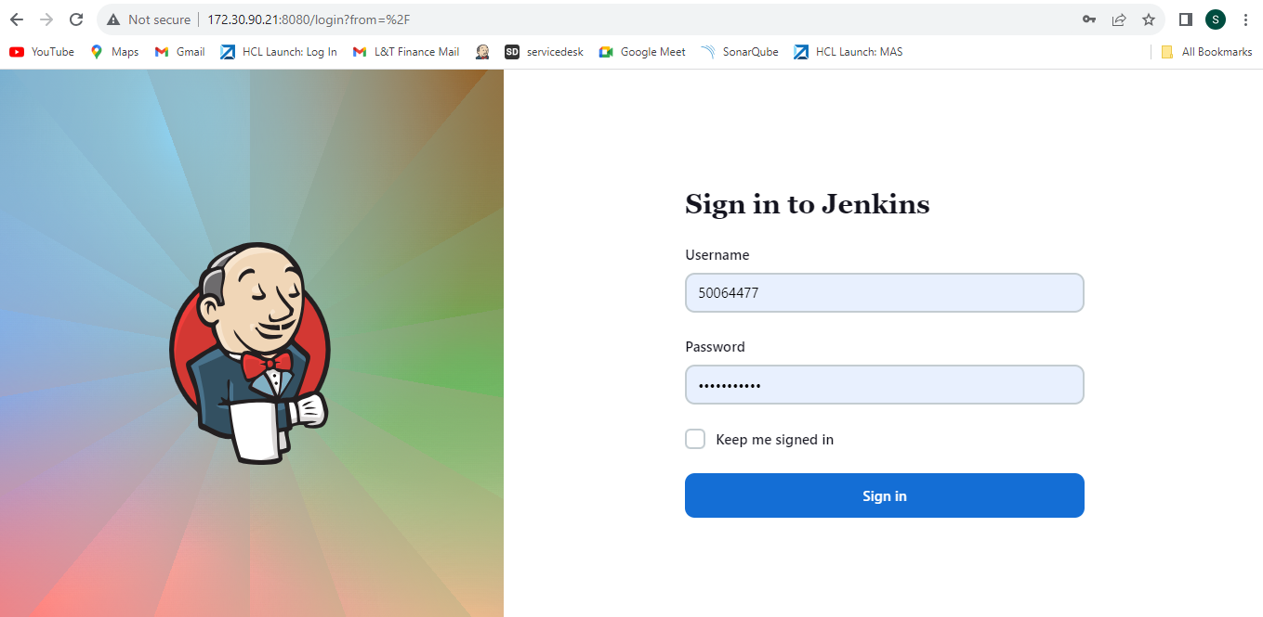
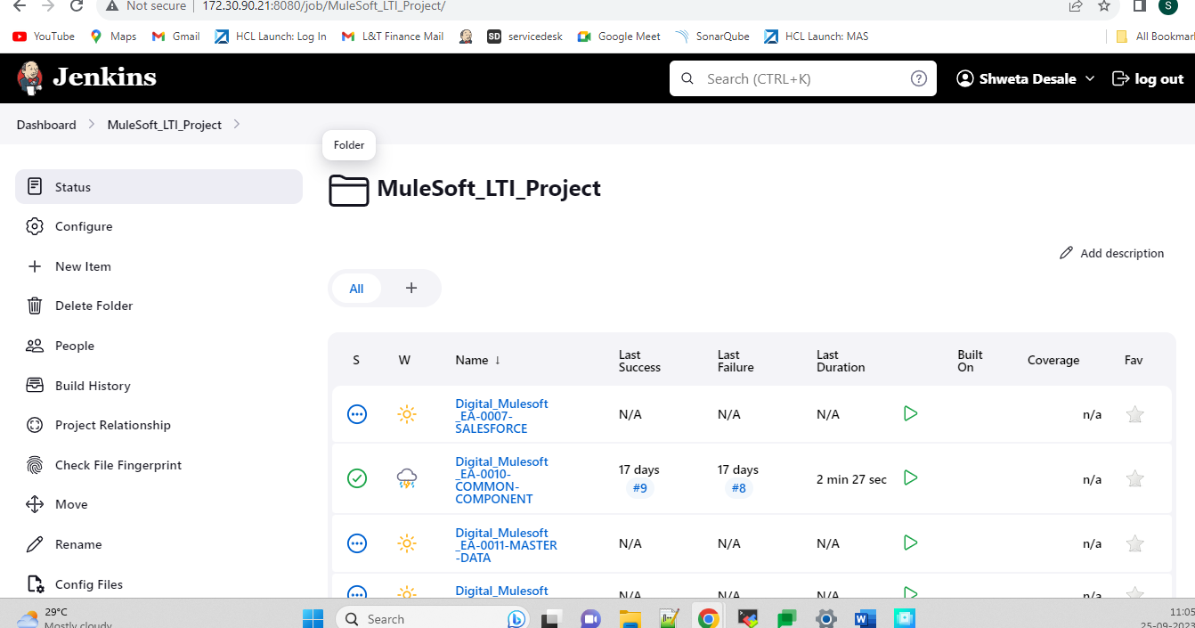

Jenkins Pipeline configuration to implement Continuous Integration

A Pipeline is a definition of a job that has some stages executed respectively. Each stage has a steps section that includes commands which should be executed respectively to complete that stage. With the pipeline, we define how Jenkins should complete the CI/CD process for our applications.

Stages in CICD pipeline:

- Clean the workspace.
- Checkout new committed code from github
- Code scanning through Sonarqube
- Run Unit tests if they are present.
- Build the artifcats
- Publish Artifacts to HCL Launch to create version.

- Clean the workspace:
This step will delete previous code directories from Jenkins workspace folder. It is only applicable to pipelines where it is needed.

- Checkout new committed code from github
In this stage, new code will be pulled from GitHub repositories to Jenkins workspace folder .

- Code scanning through Sonarqube
Newly pulled out code will be scanned by Sonarqube Analysis . We can configure different quality gates as per requirement of application.

- Run Unit tests :
Munit testes will run on code which are configured from application side if Maven package is used for building the artifacts.

- Build the artifacts:
Artifacts (JAR,WAR,BAR) is build through Jenkins using different Build Tools like Maven and Ant.

- Publish Artifacts to HCL Launch:
The newly created artifacts will be published to HCL Launch for further deployment process.

Instructions to follow steps for building pipelines and checking the logs.
Stage 1. Continuous Integration build process through Jenkins

Once code is pushed to required GitHub branch, login to Jenkins portal as mentioned above

Following are the steps to check the location of Jenkins job and build the same ..

1.1) Go to MuleSoft_LTI_Project on Dashboard.

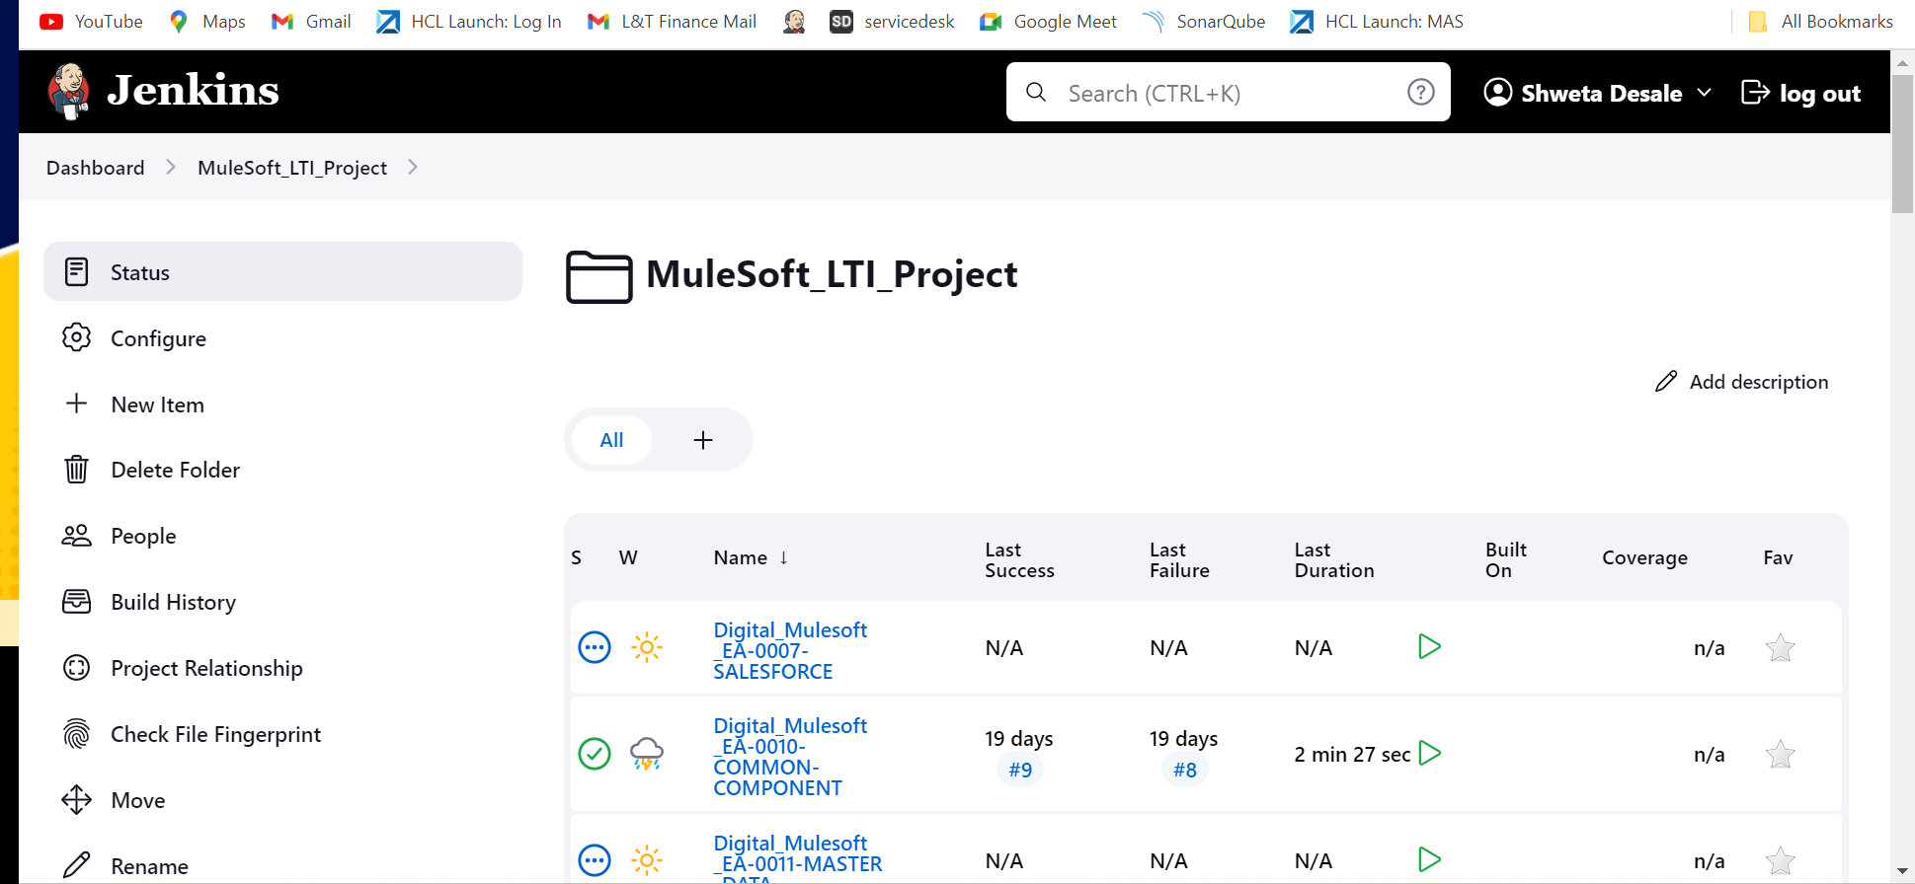

1.2) Click on Application from the list for e.g.: Digital_Mulesoft_SA-0003-DATAWAREHOUSE

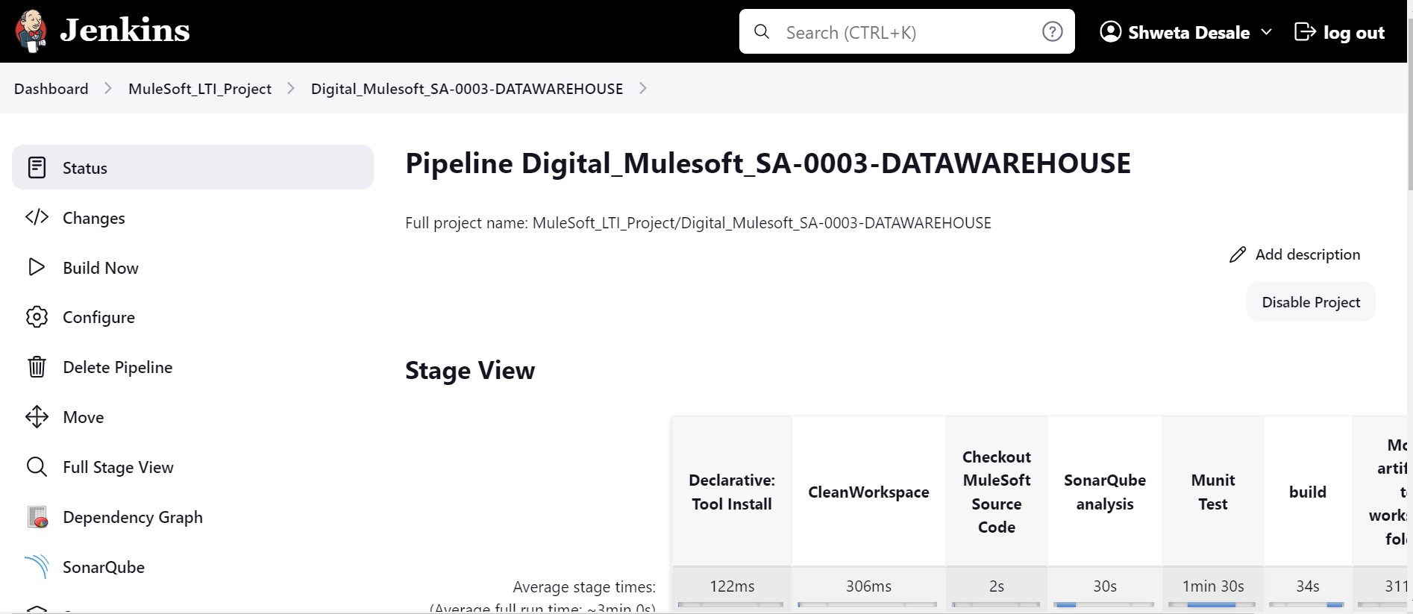

1.3) One Application is selected, now Click on Build now option from left hand side to start CI build process.

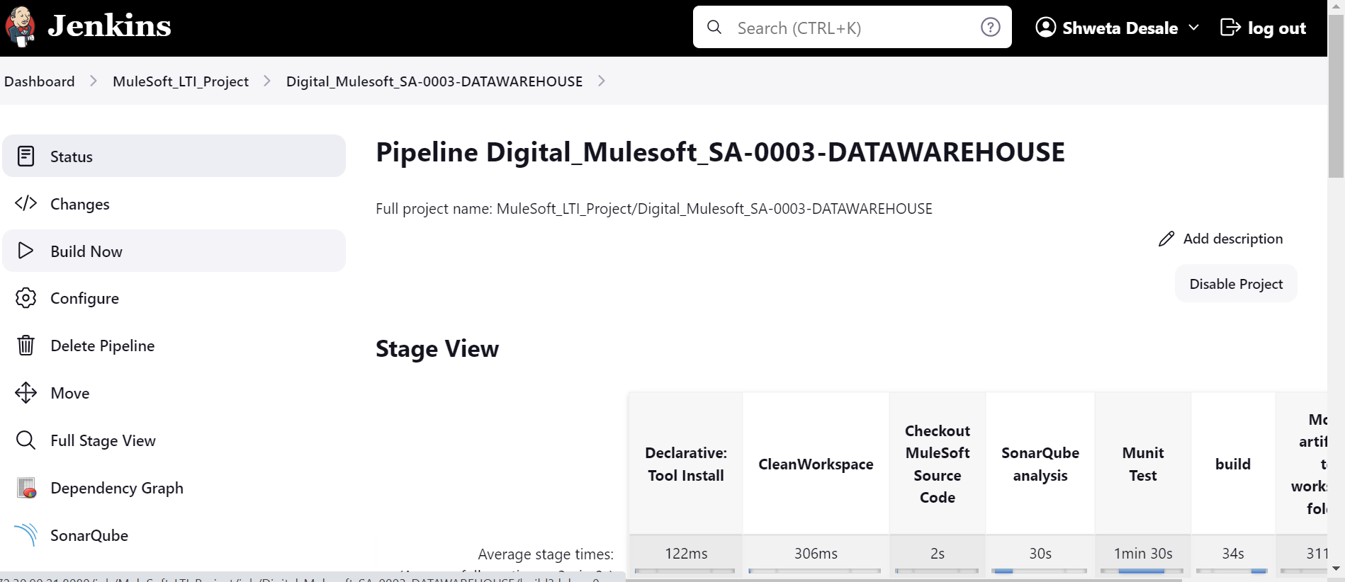

1.4) You can see build progress in Stage view.

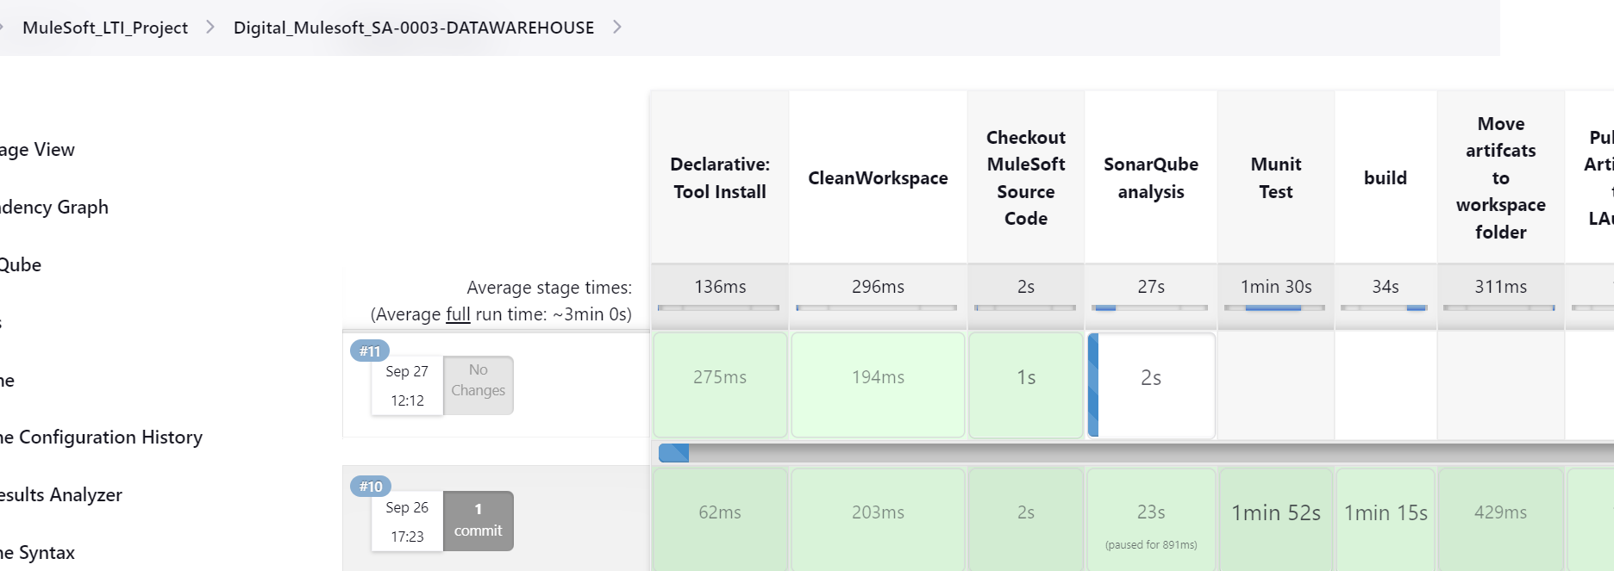

2.5) Once build is successful , you can check sonarqube analysis report from below link. Everyone is provided with Read access to it.

Sonarqube analysis link :

http://172.30.90.22:8443/

2.6) Click on project tab to see all reports .

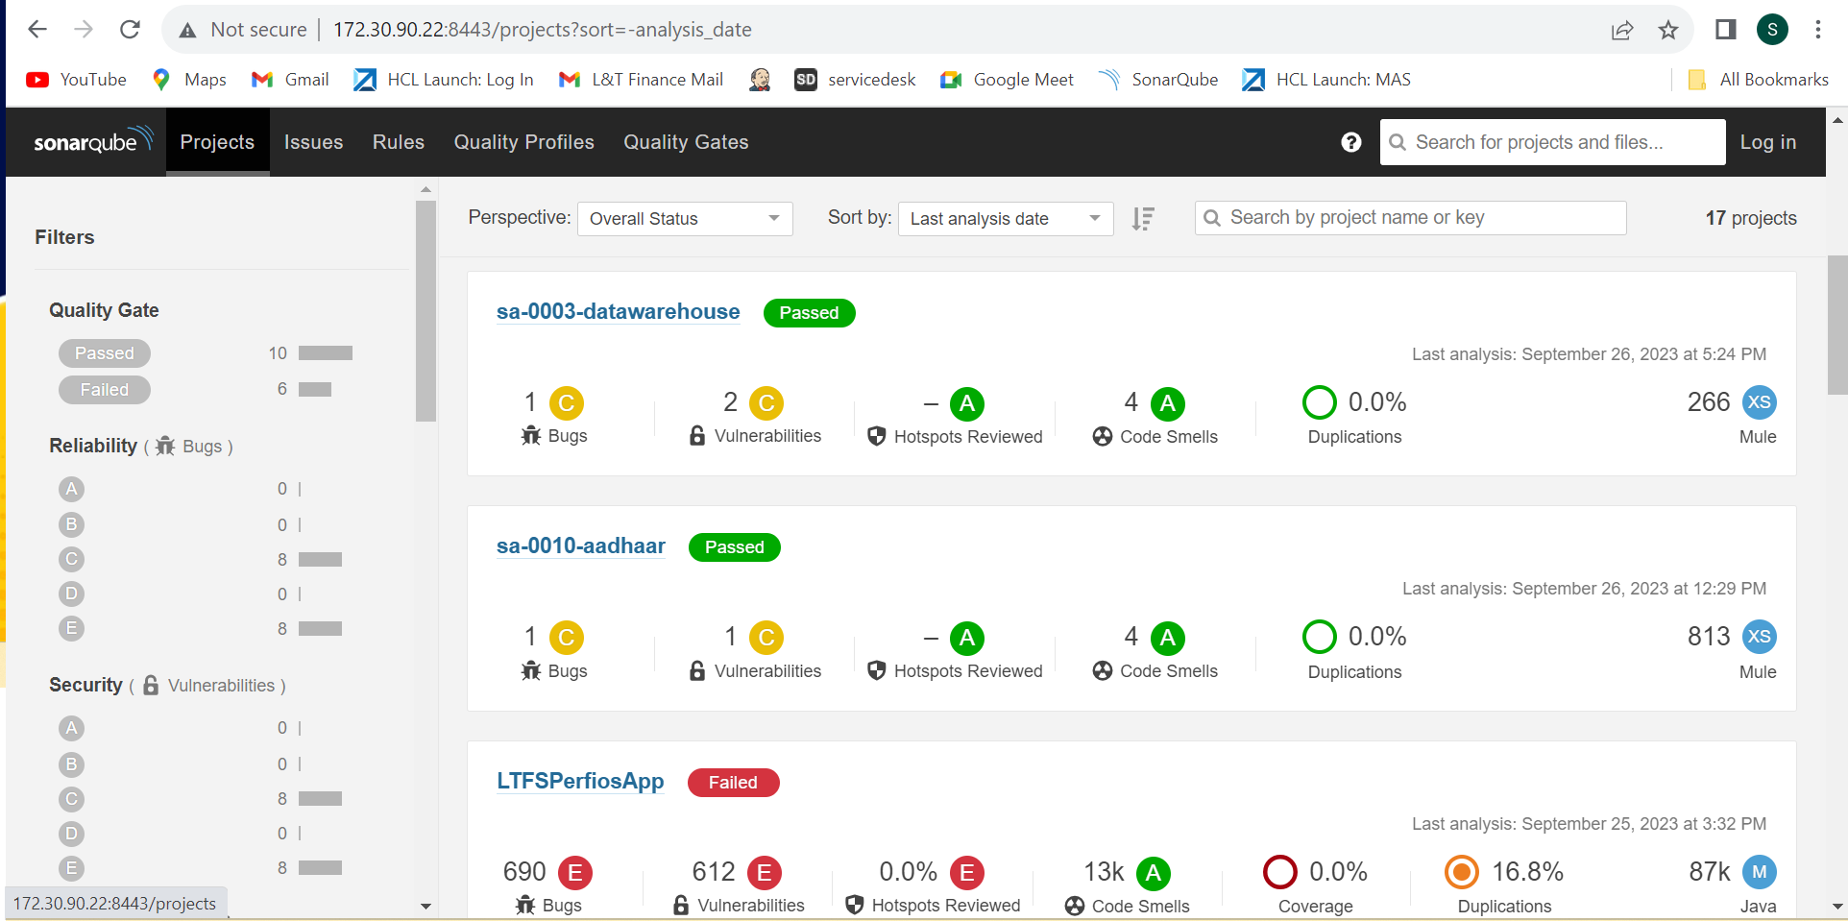

2.7) Then click on project name to see detailed report and summary of analysis.

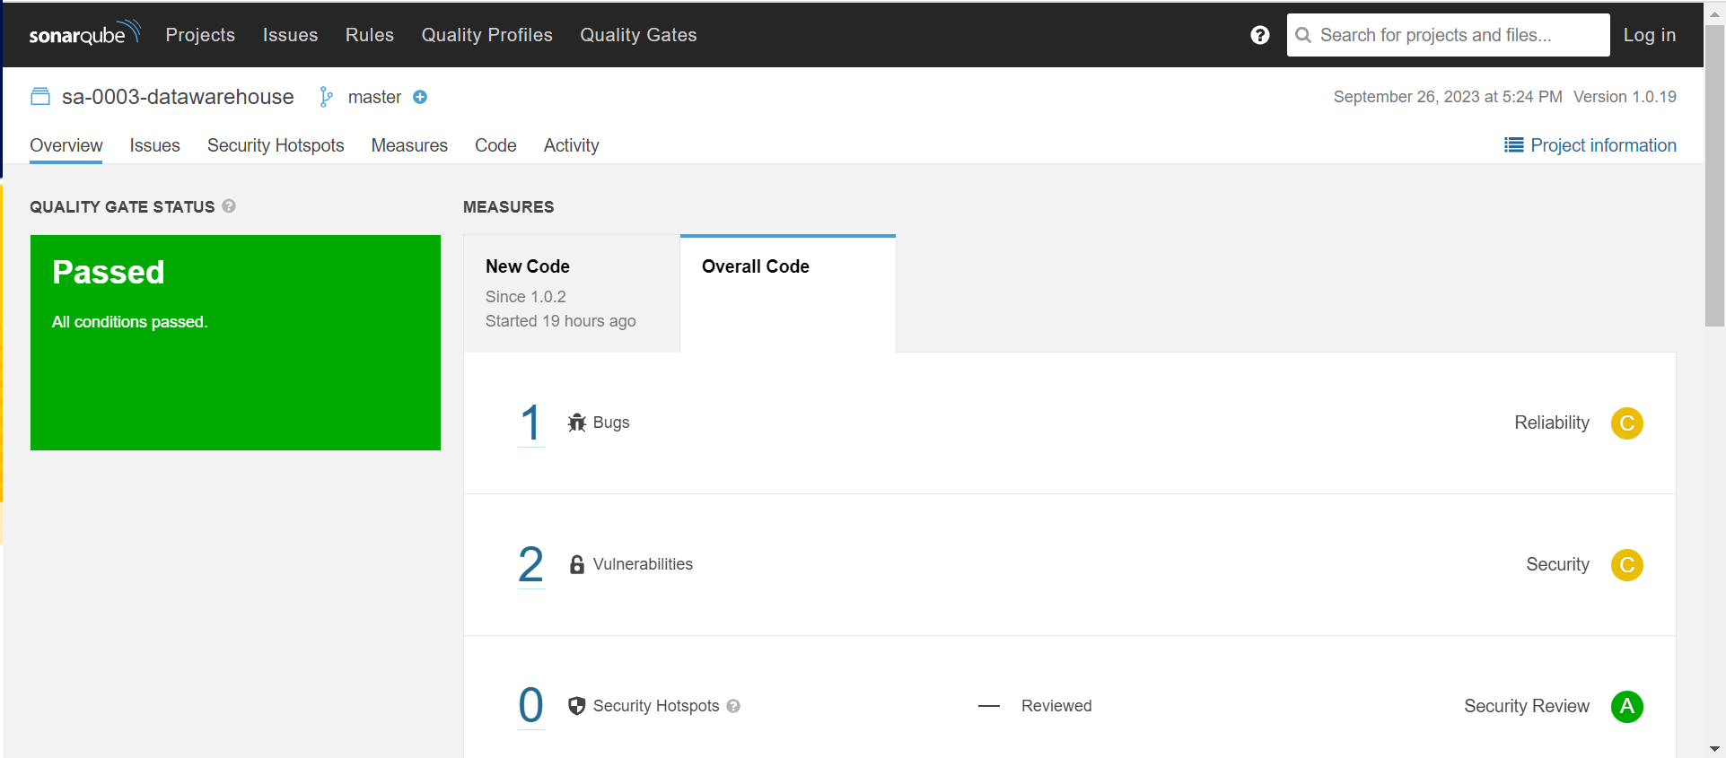

Stage 2. Checking logs of Jenkins Build

2.1) Once Build is completed (Success/failure), click on Build History on left side of the screen and click on the recent build number to see logs.

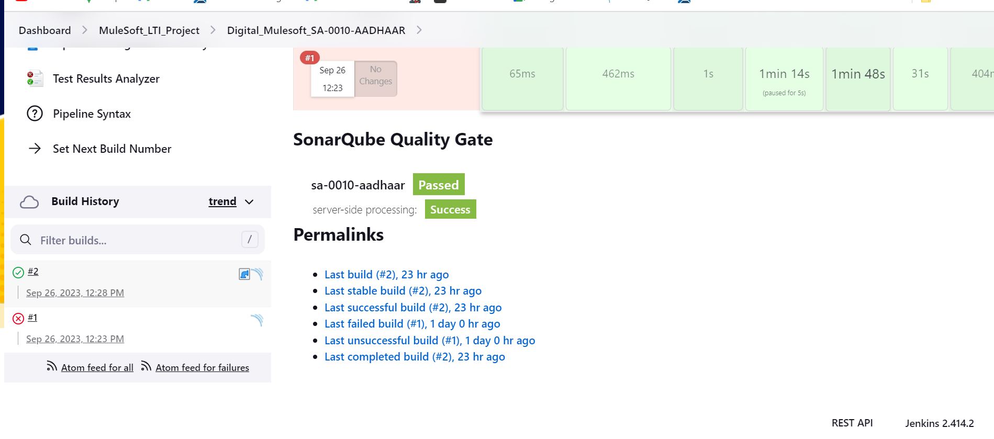

2.2) Click on Console Output to check detailed log.

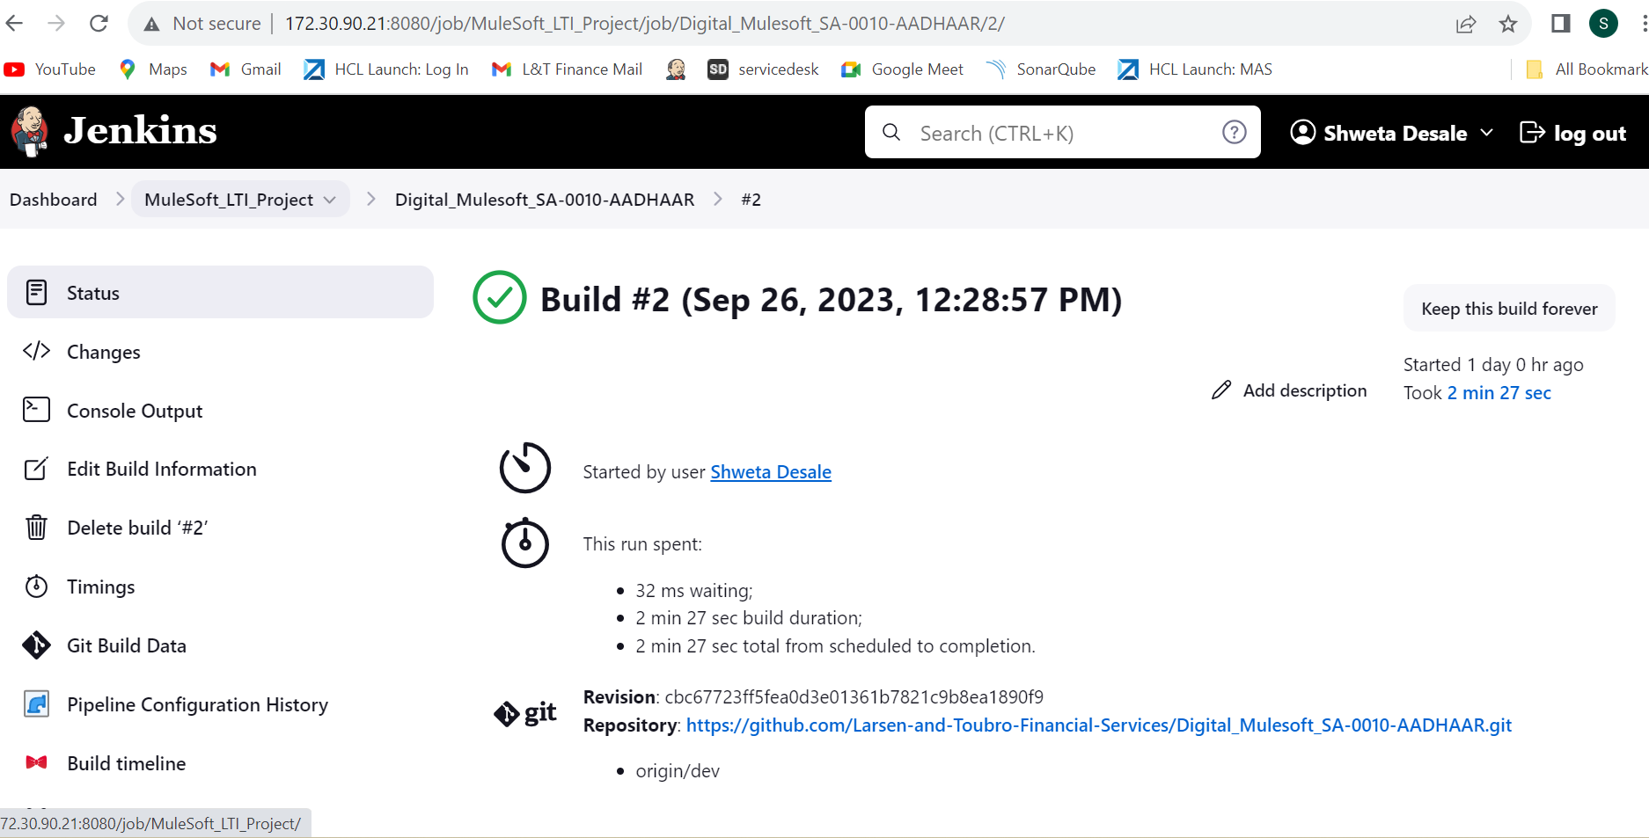

2.3) Check the detailed log here in console output.

